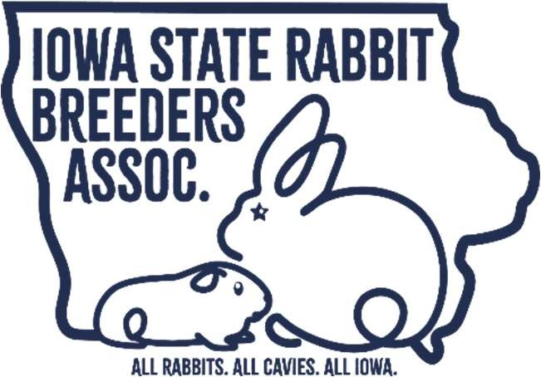
Iowa State RBA Youth Contests
October 3rd, 2026 Contests begin at 8:30am, Boone County Fairgrounds, Boone, Iowa
PURPOSE
To Acknowledge excellence among ISRBA youth members in attendance at the ISRBA State Convention and Show to allow youth members to demonstrate a working knowledge of the rabbit and cavy industry; To explore critical thinking skills, demonstrate personal initiative and provide problem-solving, decision making and goal setting activities. The ISRBA considers the entrants and participants in this Royalty Contest to be our ”Best & Brightest” for the continued strength and growth of our organization.
RULES
1. Iowa residents must be current ISRBA members by July 1, with a 30-day grace period for membership renewal. Out-of-state youth must be current ISRBA members and members of an Iowa-chartered club by July 1 with a 30-day grace period to be eligible for an ISRBA Youth Royalty title. Attendance at the State Convention is required. All selected Royalty winners must remain an ISRBA current member the entire time the position is held by the Royalty winner.
2. The application must be emailed to Andrea50548@gmail.com. Applications will be attached. All Questions must be fully answered to avoid point deductions. All applications must be signed to be eligible.
3. Application Deadline is 11:59 pm on August 29th, 2026. No late applications will be accepted.
4. Send in a photo of yourself with the application. This photo is part of your application and will be used in the Hawkeye News if you are a Royalty winner. It will also be used as a press Release photo and sent to your local paper. The best photo would be head and shoulders or waist up. You may include a rabbit or cavy in your photo. Applications received without the photo will incur a 10-point deduction from the overall score.
5. Domestic Rabbit Bio: See instructions at the end of the application. This is required and must be separate from your application.
6. Contests must be started before 1pm. The youth committee will be flexible to accommodate youth showing, but a good faith effort by contestants is expected so that the scores can be figured and animals released to breeders. If good faith effort is not shown this could result in disqualification.
7. Contestants are required to finish a segment before leaving the area. If you leave the area during a segment your score will be figured by what you have at this point. For example, a contestant can not start breed ID, leave to show rabbits, and come back to finish breed ID.
8. All Royalty will be expected to participate in State Youth Fundraising and Activities to the best of their abilities.
9. Queen Winner will be present at the Iowa State Fair for the show and crowning ceremony. All other winners will be asked to participate and help at the state fair. If a conflict arises, it is the contestant's responsibility to address this with the Youth Committee.
10. All Contestants are required to help after the state show ends. You will report to the youth area for clean up. All tests will be handed back AFTER clean up is finished.
11. Absolutely no phones on your person or with you during any and all testing for royalty.
DIVISIONS
 | 15-18 years | 12-14 years | 9-11 years | 5-8 years
Boys | King | Duke | Prince | Lord
Girls | Queen | Duchess | Princess | Lady
Age is determined by the contestant’s age on the last day of the State Convention.
Winners will be announced after the conclusion of all shows on Saturday.
CONTEST SCORING
Final Scores for the Royalty Contests will be the sum of the scores for each of the three components of the contest. The components are: Written Examination (200 points), Breed Identification (200 points), and the age-appropriate Individual Judging/Showmanship Contest (200 points).
Iowa State RBA Youth Contests Application
October 3rd, 2026 Contests begin at 8:30am, Boone County Fairgrounds, Boone, Iowa
Contact us at (515) 890-0448 or Andrea50548@gmail.com

First and last name
Email
Age
Birth date
Address
Phone number

What do you want to participate in?
 | Royalty contest (breed ID, written exam, and judging for youth 12-18 or showmanship for youth 5-11)
 | Individual contests only, please circle/highlight contest(s):
Breed ID  Written Exam |  | Showmanship (5-11 YEARS OLD ONLY)  Judging (12-18 YEARS OLD ONLY)

- Readers or writers are available to anyone who needs help. Do you require any special accommodations to participate? Please circle below.

Reader Writer

- Circle your age division below.
 | 15-18 years | 12-14 years | 9-11 years | 5-8 years
Boys | King | Duke | Prince | Lord
Girls | Queen | Duchess | Princess | Lady

- Royalty application questions and bio:
(If you win this award, a short description of your achievements will be printed in Hawkeye News. Write what you would like to be printed in 500 words or less. Applications received without the bio will incur a 20-point deduction from the overall score.) Write in form for press Release.
  - You and your parents name?
  - Where do you live?
  - Where do you attend school?
  - Are you involved in any other activities or clubs outside of rabbits?
  - When did you join the ISRBA?
  - Explain how and why you got started in Rabbit project. Include who helped you get started and the breeds you have raised?
  - What breeds do you currently raise?
  - List current memberships in rabbit and cavy organizations including the name and how long you have been active?
  - Give an example where you have helped others through your rabbit project?
  - What achievement are you most proud of in this project?
  - What are your future goals in raising rabbits?
  - What would winning royalty in the ISRBA mean to you?
  - How do you think that raising and showing rabbits and cavy has helped you for future endeavors?

- Name and email address of local paper for news release: ___________________________________________________________________________________

*Rules of conduct for all contestants: Must show good sportsmanship at all times during royalty competition and all shows during their reign. All Royalty contestants and winners should act responsibly at all shows and events where they are representing the ISRBA. This will include any and all rabbit-related activities, in any location during their reign. It is an honor to be Royalty as you are a goodwill ambassador for the ISRBA. Any actions of vandalism, theft, or use of illicit or illegal substances, including drugs and alcohol, are strictly prohibited. Those who engage in such activities will be turned over to the proper authorities. The ISRBA also reserves the right to remove any youth from their Royalty position and “member in good standing” status.

*All ISRBA ROYALTY TEAM members must comply with the dress code; if asked to change, they must change into appropriate attire. Bring and have on your royalty crown/hat with you to every event. Royalty members are expected to help with any shows/events they attend. Help present awards, write, or sort cards as age appropriateness allows.

*I authorize the ISRBA or their assignees to record and photograph my child’s image and/or voice for use in ISRBA educational and promotional programs or newsletters. I also recognize that their audio, video, and image recordings are the property of the Iowa Rabbit Breeders Association, Inc.

*Royalty Etiquette: The Royalty Team must exhibit exemplary behavior at any time he/she is representing the ISRBA, including times when he/she may not be wearing his/her crown and/or jacket. The Royalty member must maintain ISRBA membership for the duration of his/her reign. *Smoking and drinking of alcoholic beverages in public situations are not allowed and could lead to forfeiture of his/her title. Body piercing and tattoos should be concealed or in good taste to project the professional and wholesome image of the royalty program and the industry. Professional behavior and appearance is critical at all times, including any and all social media or online venues. Appropriate Language is expected at any and all events.

*If disciplinary problems arise during the reign, the issue will be submitted in writing to the board. ISRBA Board of Directors will review the problem. If behaviors that do not reflect positively on the ISRBA occur and/or upon the decision of the Activities Committee, the Royalty member will lose his/her title and the runner-up will assume the duties. The decisions of the committee are final.

*I have read and understand the above duties and etiquette outlined by the Iowa State Rabbit Breeders Association and Iowa Youth Activities Committee. I agree to the guidelines, rules, and responsibilities as specified above and will uphold them to the best of my abilities. I understand that if I do not maintain the above accountabilities, at the discretion of the board of directors, I will be removed from royalty and forfeit my title as Iowa Royalty.

Type or sign name of ISRBA member as signature:_________________________________

Type name of parent/guardian as signature:_______________________________________

